SES-Simple Email Service

Objectives-
• Learn basics of Amazon SNS
• Create and manage SNS topics
• Add and confirm subscriptions (Email/SMS)
• Send messages to multiple users
• Understand notification delivery process
• Integrate with Amazon Web Services services
• Ensure security using AWS Identity and Access Management
• Build real-time notification system
Step 1- Open AWS and search SES.
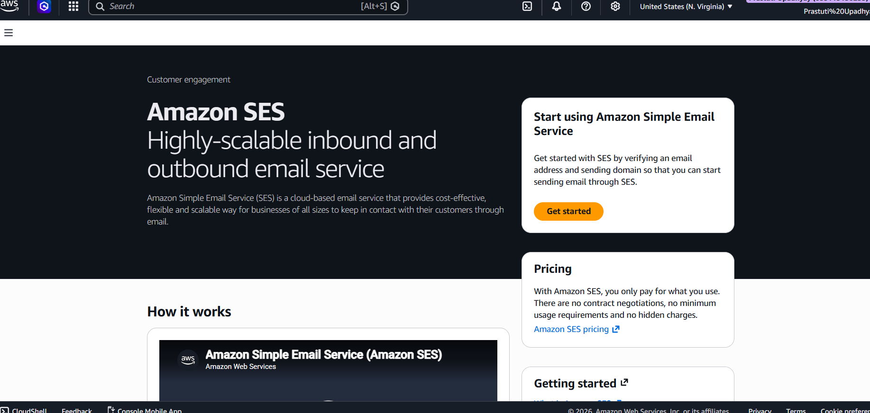
Step 2- In Amazon SES select Identities. Then click on Create identity.
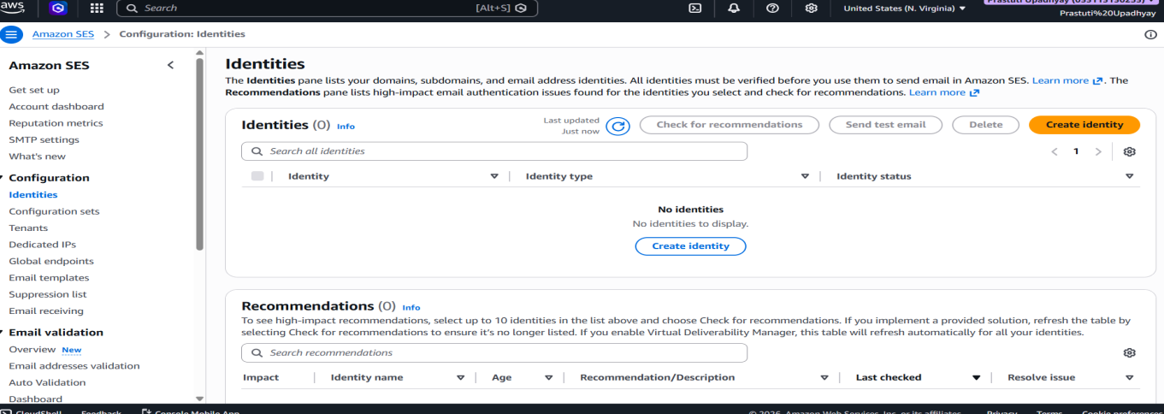
Step 3- Under Identity details in Identity type select Email Address.
Then write your email in email address (prastutiupadhyay33@gmail.com) then click Create identity.
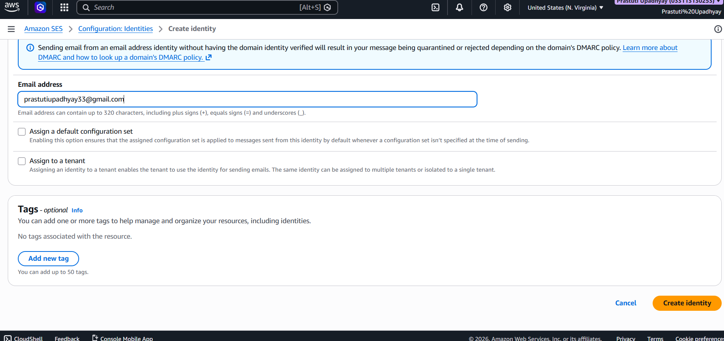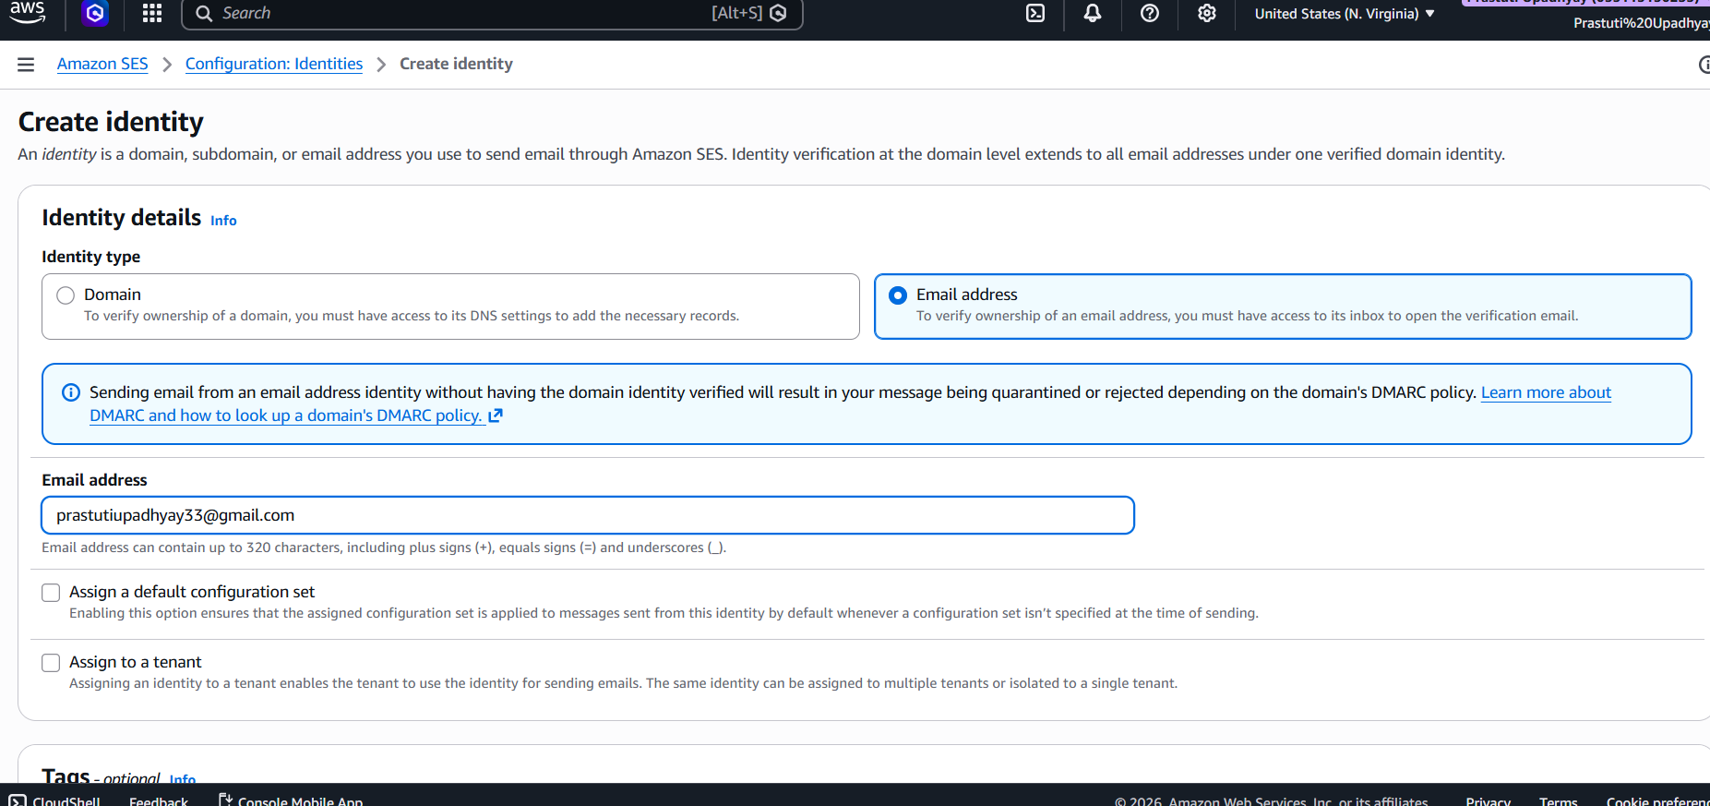
Step 4- You get the verification email on your email address we have to open that and click the link below for confirmation.
Now your email is created in Identities.
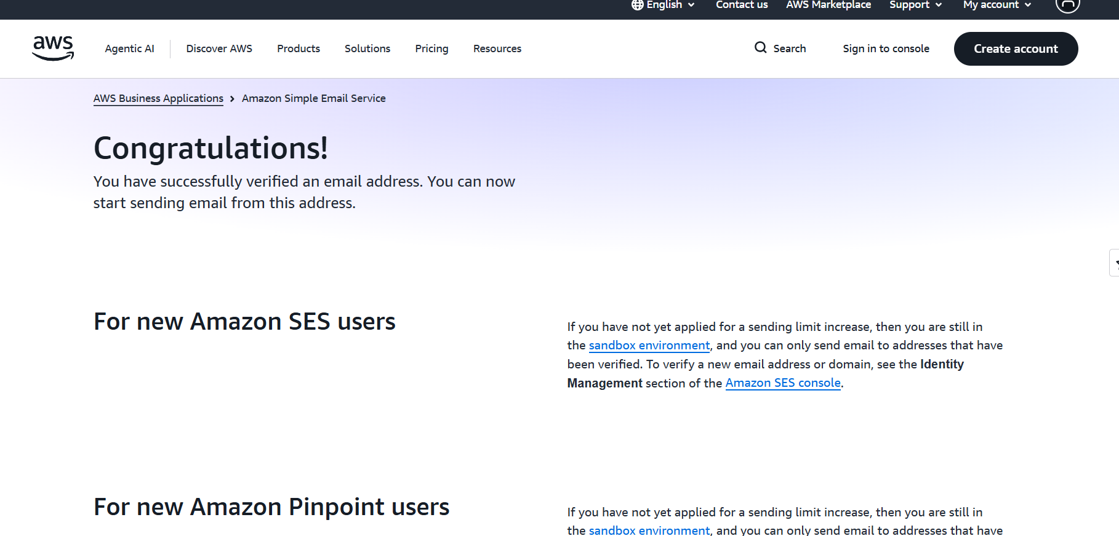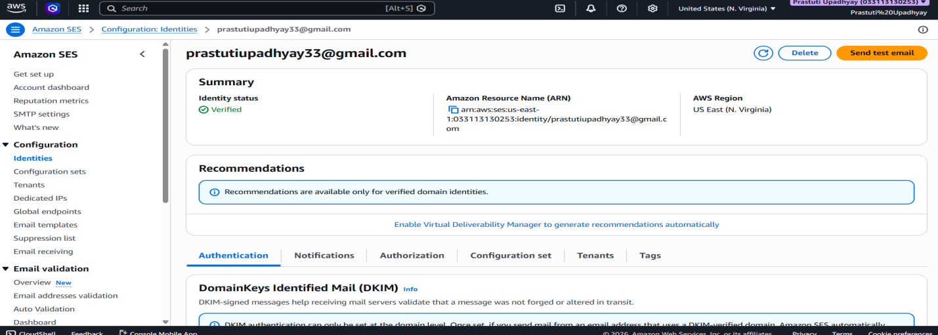
Step 5- Select the email which we created then click on Send test email .
1- Under message details in email format select Formatted.
2- In Scenario we can select by own, like I have selected Complaint.
3- Then in Subject we can write by our own, like I have written Billing Issue.
4- Then In Body also write your own, I have written Hello.
5- Then click on Send test email.
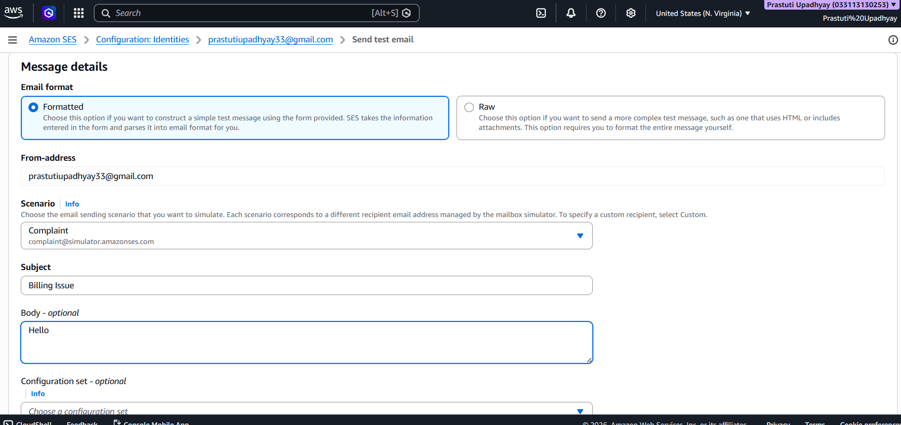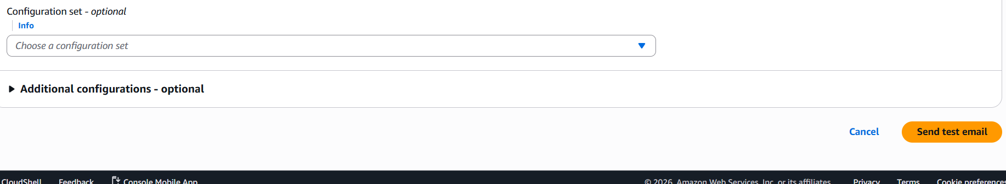
Step 6- Confirmation of successfull verification. We get a green colour notification in this when we sent a test email to complaint@simulator.amazonses.com.
